# Calculate Number of Shares Outstanding

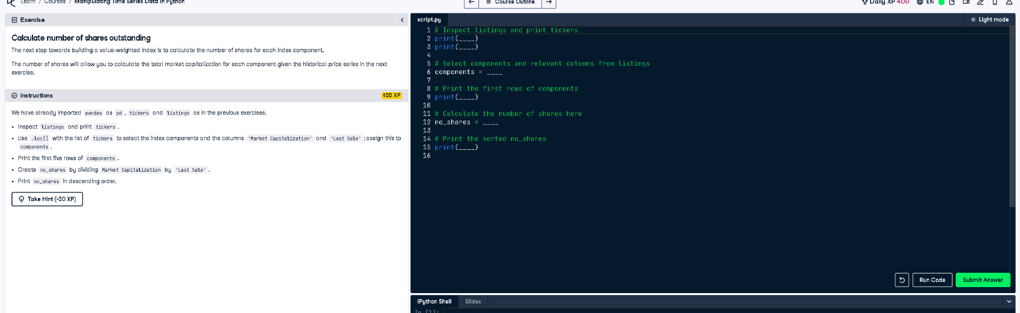

## ✅ Full Correct Code:

# Inspect Listings and print tickers  
print(listings.info())  
print(tickers)  
  
# Select components and relevant columns from listings  
components = listings.loc[tickers, ["Market Capitalization", "Last Sale"]]  
  
# Print the first five rows of components  
print(components.head())  
  
# Calculate the number of shares here  
no_shares = components["Market Capitalization"] / components["Last Sale"]  
  
# Print the sorted no_shares  
print(no_shares.sort_values(ascending=False))

## 📘 Explanation (Simple Terms):

This code calculates how many shares are outstanding for each selected company. It first extracts market cap and last sale price, then divides them to get the number of shares. It prints the top 5 companies and finally shows the number of shares sorted in descending order for easier analysis.